QR Code Tool installation instruction

**Step 1. Install Python 3**

The QR Code Tool required to run in Python 3. If you don’t have Python 3 installed on your computer, you need to download Python 3 from <https://www.python.org/downloads/>.

During the installation, select the option to “Add Python to PATH”:

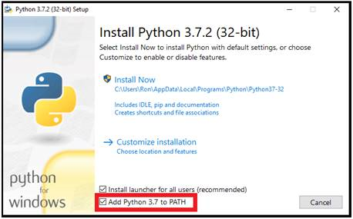

Note: EPA users may not have permission to install and need to ask IT support to give permission.

**Step 2. Install Python packages**

The QR Code Tool requires these Python packages: pyzbar, imutils, qrcode, Pillow, opencv-python, office365

With Python 3 installed, ‘pip’ is installed automatically. Use ‘pip’ to install required Python packages.

Find location where Python 3 installed in your computer. For EPA Laptop, here is the typical location:

*C:\Users\<Your Username>\AppData\Local\Programs\Python\Python37*

Open a “Command Prompt” window: right-click on the Windows Start Menu and select “Run”. Type “cmd” in the entry field provided.

From the command prompt, navigate to the Python 3 Script directory by typing:

*cd C:\Users\<Your Username>\AppData\Local\Programs\Python\Python37\Script*

Type the following lines one by one in ‘Command Prompt’ to install packages:

*pip install pyzbar*

*pip install imutils*

*pip install qrcode*

*pip install Pillow*

*pip install opencv-python*

*pip install Office365-REST-Python-Client*

**Step 3. Create Application Key for SharePoint Site**

If you need to write QR Code to a SharePoint Site, you need to create Application Key for the site in order for Python script to access the SharePoint site. You need to have admin right to create application key.

The instructions for setting up the application key are located here:

<https://docs.microsoft.com/en-us/sharepoint/dev/solution-guidance/security-apponly-azureacs>

Here is the example SharePoint site URL:

<https://usepa.sharepoint.com/sites/Emergency%20Response/EOCIncident/>

To create an application key, run the URL (example):

<https://usepa.sharepoint.com/sites/Emergency%20Response/EOCIncident/_layouts/15/AppRegNew.aspx>

The following screen will show:

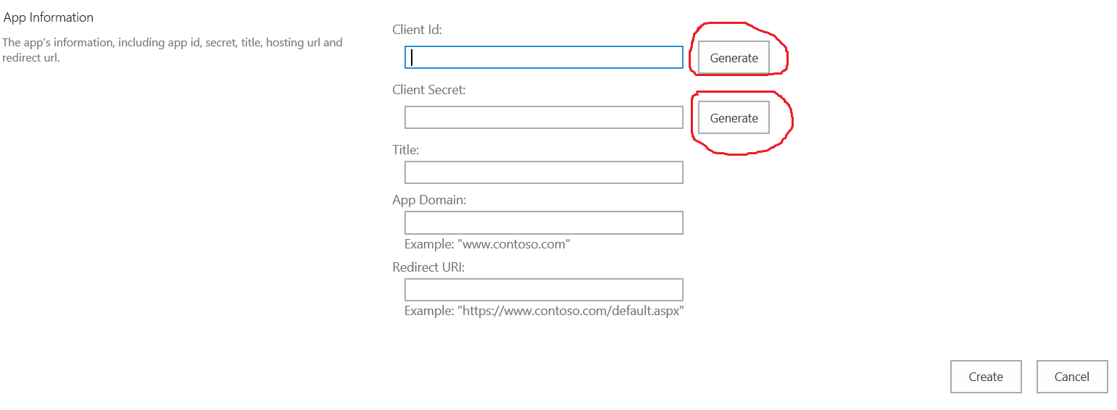

Click “Generate” button to generate Client Id and Client Secret. Write down Client Id and Client Secret for next step to use. Enter Title that is meaningful for you.

Title: your tile

App Domain: www.localhost.com

Redirect URI: <https://www.localhost.com>

Click “Create” button to create.

Then run the following URL (example):

<https://usepa.sharepoint.com/sites/Emergency%20Response/EOCIncident/_layouts/15/AppInv.aspx>

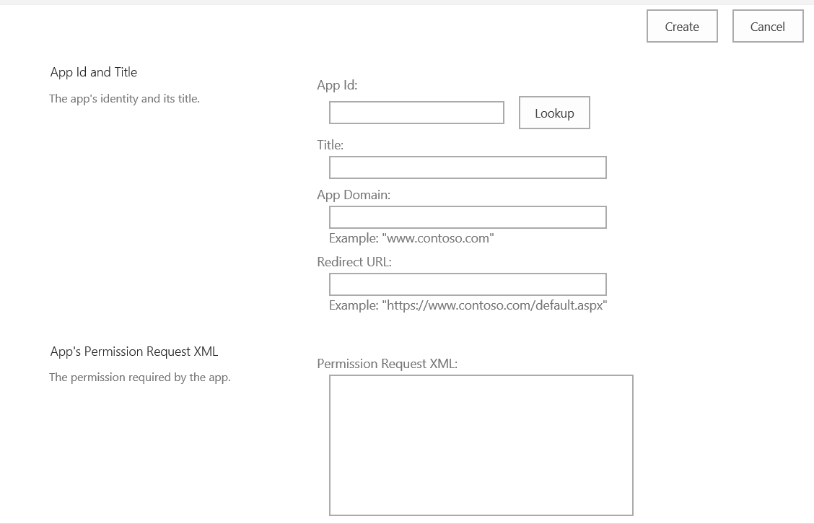

Enter the Client id and click ‘Lookup’ button.

In the ‘Permission Request XML:’ box, enter the following:

<AppPermissionRequests AllowAppOnlyPolicy="true">

<AppPermissionRequest Scope="http://sharepoint/content/sitecollection/web"

Right="FullControl"/>

</AppPermissionRequests>

Click the ‘Create’ button to finish.

**Step 4. Get the QR Tool Python Scripts**

Download QR Tool files from https://github.com/timb0e/QR_Tool

Copy the QR Tool python script QRToolbox.py and the setting.py config file to a folder on your computer.

Modify settings.py file using the Client Id and Client Secret generated from the above step and enter the SharePoint site URL for ‘url’.

settings = {

'url': '',

'client_id': '',

'client_secret': ''

}

The following lines in QRToolbox.py may need to be modified:

*listTitle = "QR Timestamps" (this is the SharePoint list name for writing scanned entry to)*

*qrfolder = "QRCodes" (this is the folder name to store QR Code image files)*

*bkcsvfolder = "HXWTEST" (this is the folder name to store backup csv files)*

*qrbatchfile = "names.csv" (this is file name for batch generate QR Code images)*

*relative_url = "/sites/Emergency%20Response/EOCIncident/EOC%20Documents/QRCodes/names.csv" (this is location that names.csv resides)*

**Step 5. Run the QR Code Tool**

To run the QR tool, simply click the QRToolbox.py to run. If you have two versions of Python installed on your computer (Python 2 and Python 3), you may need to specify to run QRToolbox.py in Python 3.

The following is option:

Create a .bat file to run the QR Tool. The .bat file contains the following line:

*<python 3 exe location>/python.exe <QR Tool location>/QRToolbox.py*

Create shortcut on the desktop (optional)

Click the .bat file to run the QR Code Tool.

**Step 6. Functions in the QR Code Tool**

There are 7 functions in the QR Code Tool:

1. QR Reader: Scan the QR Code and the entry will be written into the SharePoint site.
2. QR Creator – Batch: Generate QR Code image file for each entry defined in names.csv. Sample names.csv:
   1. [*Lastname.firstname@epa.gov*](mailto:Lastname.firstname@epa.gov)
   2. [*Othername.other@epa.gov*](mailto:Othername.other@epa.gov)
   3. The names.csv must be available in the SharePoint site defined in the QRToolbox.py.
   4. *relative URL = "/sites/Emergency%20Response/EOCIncident/EOC%20Documents/QRCodes/names.csv"*
   5. You can modify the above line in QRToolbox.py to point to your own SharePoint site.
3. QR Creator – Single: Generate QR Code for single entry. This option will prompt to enter email or other ID to generate QR Code image file for the entered value. The output QR Code image file will be stored in the SharePoint Site defined in the settings.py and the folder name is defined in QRToolbox.py: qrfolder = "QRCodes"
4. Establish Share Folder: Select a folder to output QR Code images and to store the csv file for scanned entries. This option is not needed if a SharePoint connection has been established.
5. Consolidate Records: This option is used to consolidate records into one file. This option is not needed if a SharePoint connection has been established.
6. About/Credits: Display information about the QR Code Tool.
7. Exit: Exit the QR Code Tool

**Step 7. Access the QR Records in SharePoint**

A SharePoint workflow will automatically aggregate and consolidate the QR data from all input devices.